Style Hierarchy
With the various flavors of styles available (see each of the subclauses below), multiple style types can be applied to the same content within a file, which means that properties must be applied in a specific deterministic order. As with inheritance, the resulting formatting properties set by one type can be unchanged, removed, or altered by following types.
The following table illustrates the order of application of these defaults, and which properties are impacted by each:
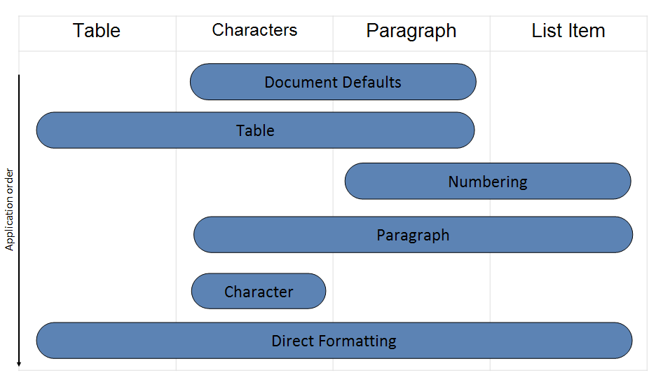
This process can be described as follows:
- First, the document defaults are applied to all runs and paragraphs in the document.
- Next, the table style properties are applied to each table in the document, following the conditional formatting inclusions and exclusions specified per table.
- Next, numbered item and paragraph properties are applied to each paragraph formatted with a numbering style.
- Next, paragraph and run properties are applied to each paragraph as defined by the paragraph style.
- Next, run properties are applied to each run with a specific character style applied.
- Finally, we apply direct formatting (paragraph or run properties not from styles). If this direct formatting includes numbering, that numbering + the associated paragraph properties are applied.

